|  |  |  |  |  |  |
| --- | --- | --- | --- | --- | --- |
| **Scope** | **Select** | **Adapt & Align Model** | | **Application Integration** | |
| Define the Problem | Choose the model | Prompt Engineering | Evaluate | Optimize & Deploy model for inference | Augment model & build LLM powered application |
| Fine Tuning |
| Align with human feedback |

**Fine Tuning**

Fine tune and LLM with Instruction Prompts:

**Limitation of in context learning(one shot, few shot):**

* For smaller models it doesn’t work even with five or six examples are included.
* Examples take up space in context window (where prompt is written).
* Instead try fine tuning the model.

In pre training where we train the model using unstructured textual data via self-supervised learning.

Fine tuning is supervised learning process where you use a dataset of labeled examples to update the weights of the LLM. The labeled examples are prompt, completion pair.

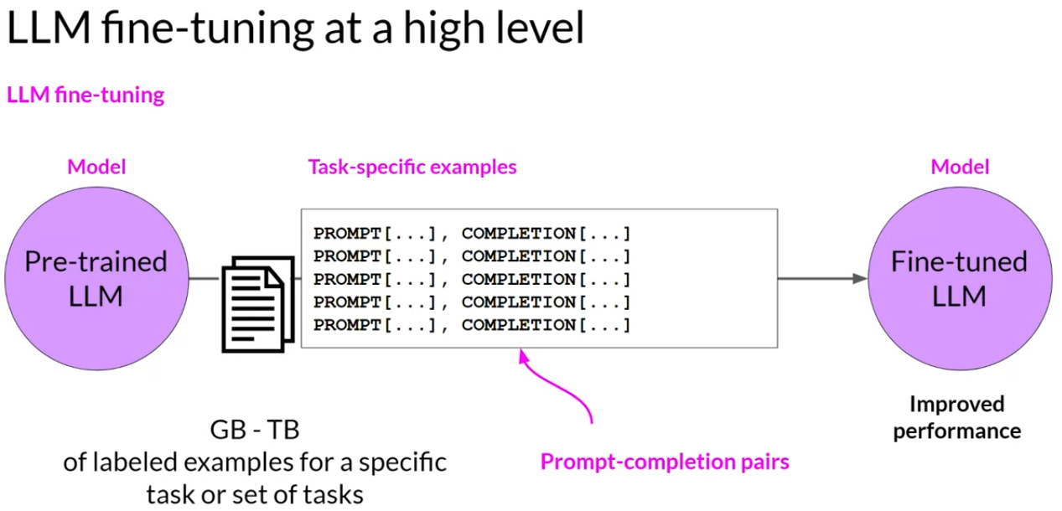

Where all the model weights are updated is known as full fine tuning.

How do you go about Instruction fine tuning an LLM:

1. Prepare your training data.
2. Divide the dataset into Training [prompt, completion], validation [prompt, completion], and test set [prompt, completion],.